Modulo 1

In this module, you will be introduced to databases. You will learn how to use basic SQL statements like SELECT, INSERT, UPDATE and DELETE. You will also get an understanding of how to refine your query results with the WHERE clause as well as using COUNT, LIMIT and DISTINCT.

- Course Introduction
- Course Overview

- Introduction to Databases
- SELECT Statement
- SELECT statement examples
- Hands-on Lab: Simple SELECT Statements
- COUNT, DISTINCT, LIMIT
- Hands-on Lab: COUNT, DISTINCT, LIMIT
- INSERT Statement
- UPDATE and DELETE Statements
- Hands-on Lab: INSERT, UPDATE, and DELETE
- Summary: Basic SQL
- Practice Quiz: Basic SQL
- SQL Cheat Sheet: Basics - SELECT, INSERT, UPDATE, DELETE, COUNT, DISTINCT, LIMIT

Modulo 2

- Relational Database Concepts
- Types of SQL statements (DDL vs. DML)
- CREATE TABLE Statement
- ALTER, DROP, and Truncate Tables
- Examples to ALTER and TRUNCATE tables using MySQL
- Examples to CREATE and DROP tables
- Hands-on Lab : CREATE, ALTER, TRUNCATE, DROP
- SQL Scripts - Uses and Applications
- Hands-on Lab: Create and Load Tables using SQL Scripts
- Summary: Relational Database Concepts and Tables
- Practice Quiz: Introduction to Relational Databases and Tables

Modulo 3

Refining your results
Using String patterns and ranges
Select * from table
Select name from table where name like ‘R%’
Select age from table where 18 <= age and age <= 32
Select age from table where age between 18 and 32
Select country from table where country = ‘FR’ or country = ‘AU’
Select country from table where country in (‘FR’,’AU’,’ES’)
Sorting results sets
Select title from table ORDER BY TITLE DESC
Select title , pages from table ORDER BY 2 DESC
Grouping results sets
Select distinct(countries) from table order by 1
Select country, count(country) as count from table group by country having count(country) > 4
SELECT DEP_ID, COUNT() AS "NUM_EMPLOYEES", AVG(SALARY) AS "AVG_SALARY" FROM EMPLOYEES GROUP BY DEP_ID HAVING count() < 4 ORDER BY AVG_SALARY;

Functions, multiple tables, subqueries

BUilt-functions: SUM, MIN, MAX, AVG
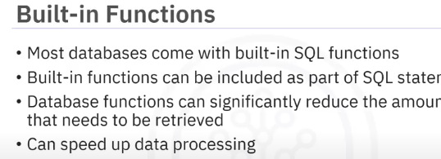
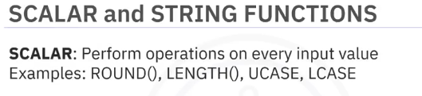

Date & time Functions
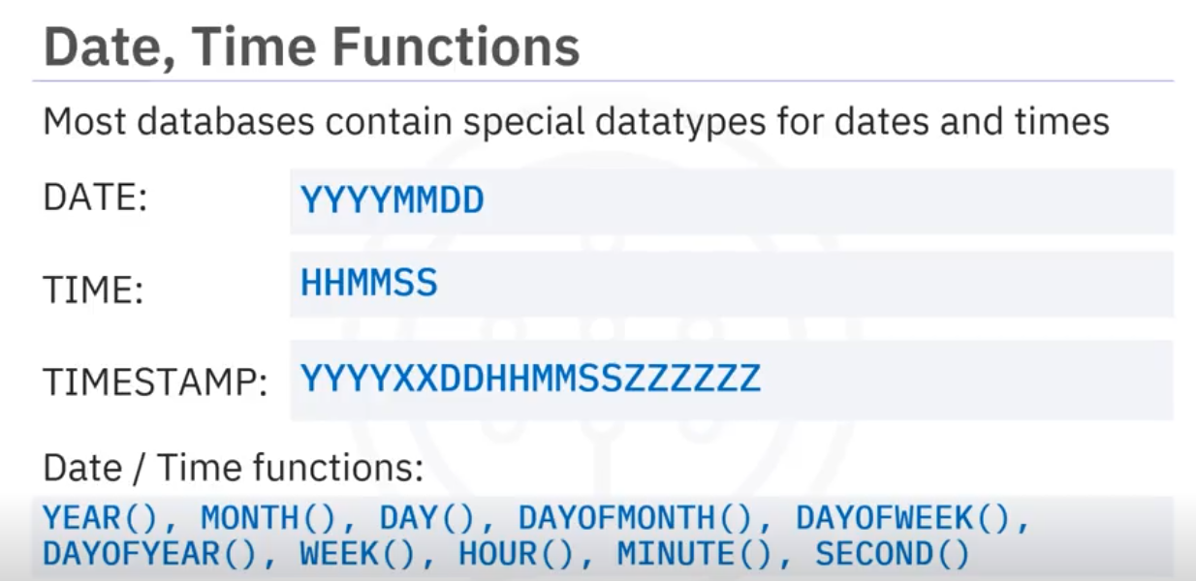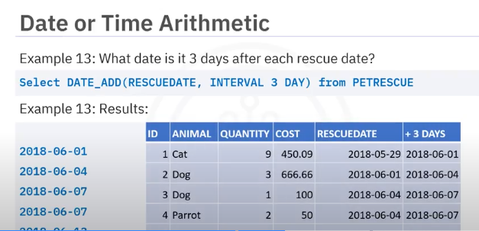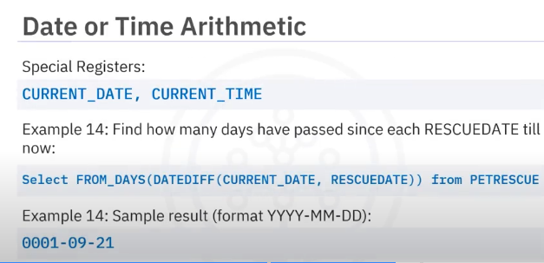SELECT SUM(QUANTITY) FROM PETRESCUE WHERE MONTH(RESCUEDATE)="05";

SUbQUeries and nested select
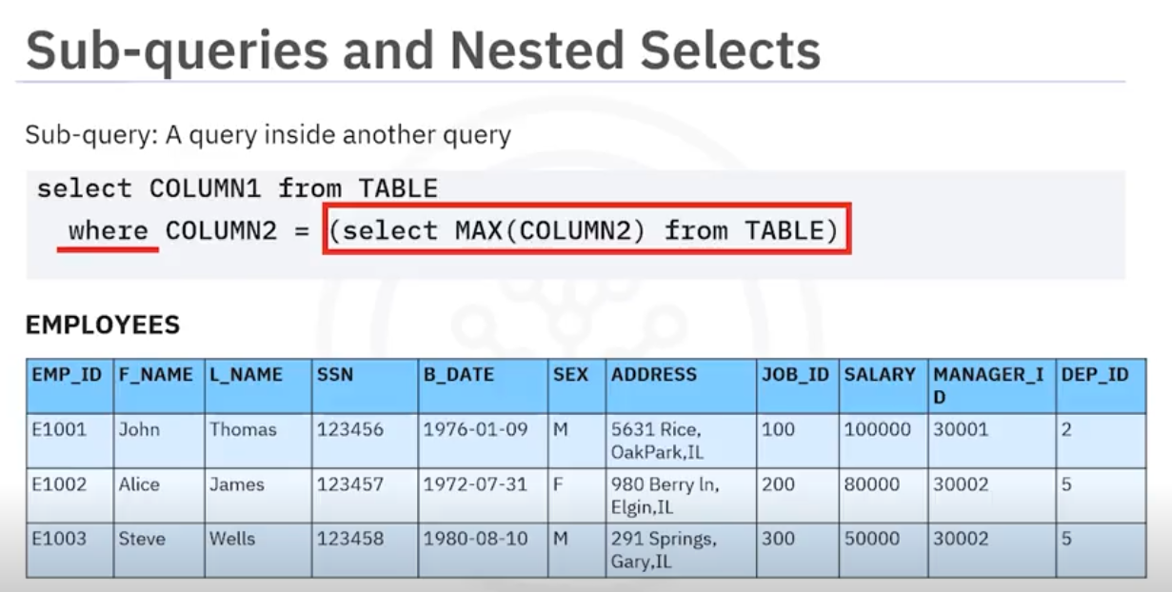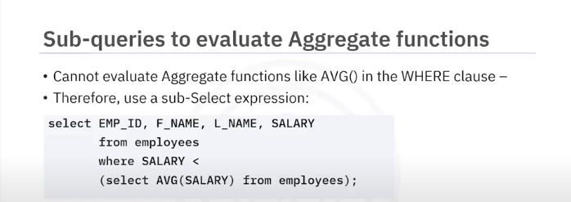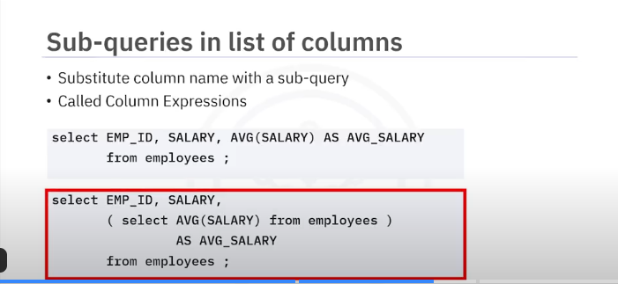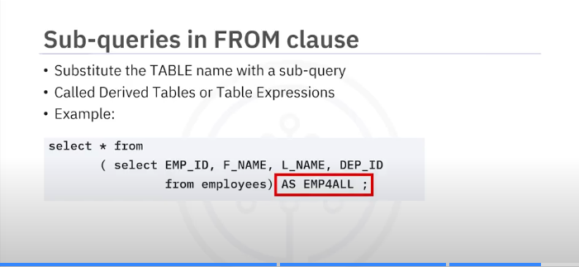Working wiht multiple tables

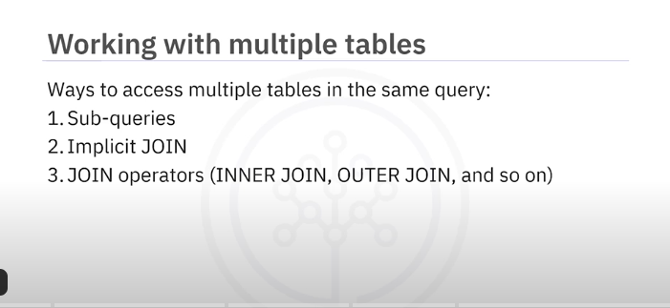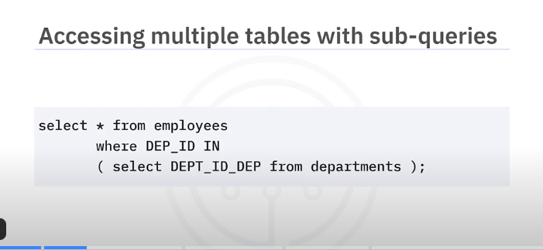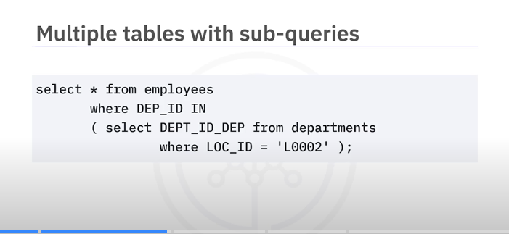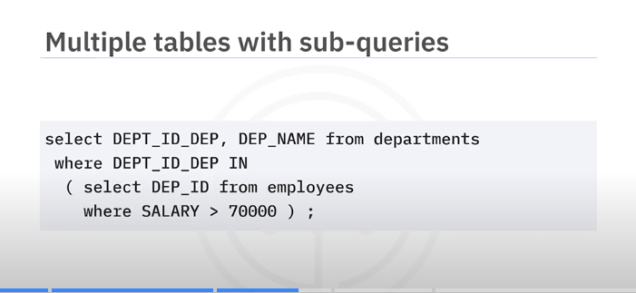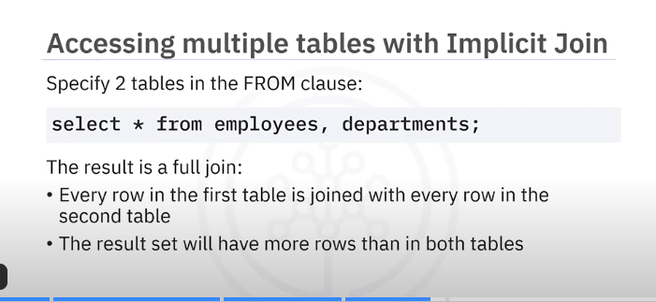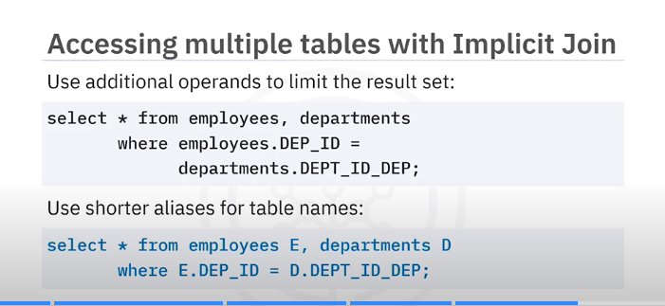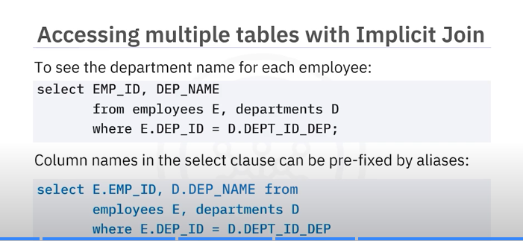

MODULO4

Accessing Data bases Using Python
Examples of notebook interfaces include the Mathematica notebook, Maple worksheet, Matlab notebook, IPython Jupyter, R Markdown, Apache Zeppelin, Apache Spark notebook, and the Databricks cloud.

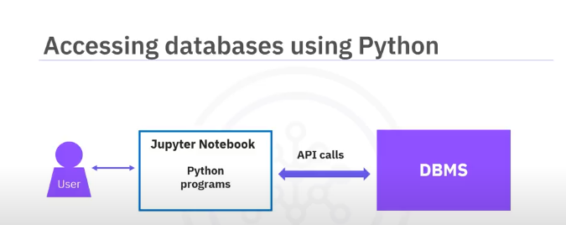
An application programming interface is a set of functions that you can call to get access to some type of service.
The SQL API consists of library function calls as an application programming interface,
API, for the DBMS.
To pass SQL statements to the DBMS, an application program calls functions in the API, and it calls other functions to retrieve query results and status information from the DBMS.
The basic operation of a typical SQL API is illustrated in the figure.
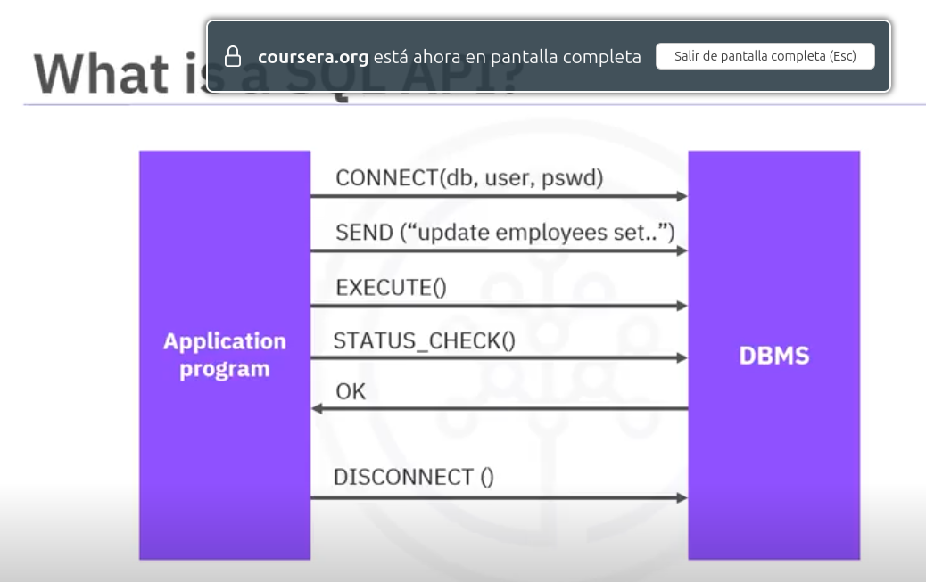
The application program begins its database access with one or more API calls that connect the program to the DBMS.
To send the SQL statement to the DBMS, the program builds the statement as a text string in a buffer and then makes an API call to pass the buffer contents to the DBMS.
The application program makes API calls to check the status of its DBMS request and to handle errors.
The application program ends its database access
with an API call that disconnects it from the database

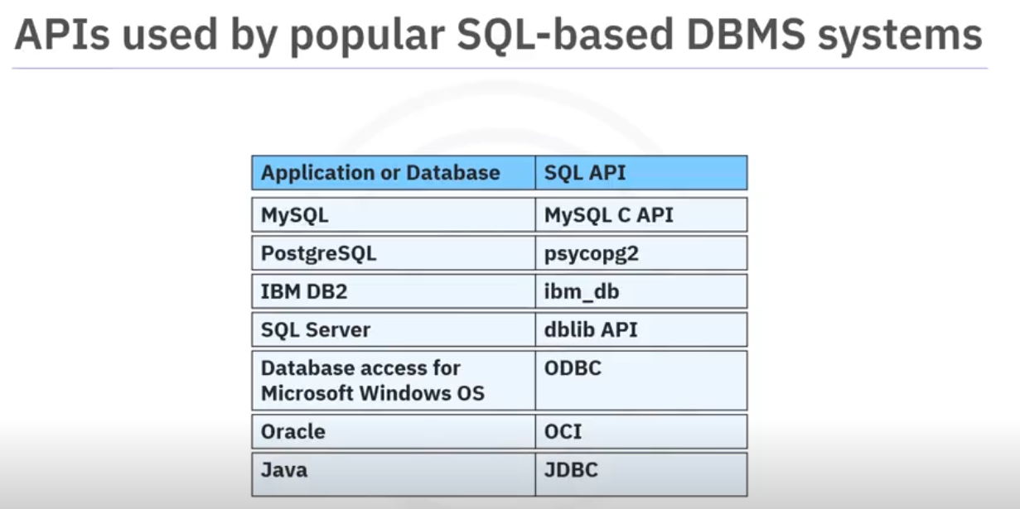
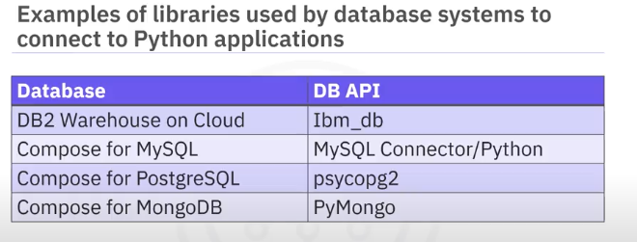

DB API is Python standard API for accessing relational databases.
It is a standard that allows you to write a single program that works with multiple kinds
of relational databases instead of writing a separate program for each one.
If you learn the DB-API functions, then you can apply that knowledge to use any database with Python.
Here are some advantages of using the DB-API.
- It's easy to implement and understand.
- This API has been defined to encourage similarity between the Python modules that are used to access databases.
- It achieves consistency which leads to more easily understood modules.
- The code is generally more portable across databases, and it has a broader reach of database connectivity from Python

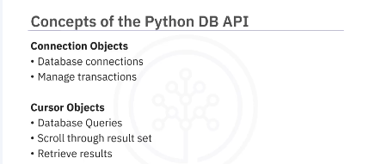
The two main concepts in the Python DB-API are :
- connection objects : connect to a database and manage your transactions
- cursos objects :run queries.

You open a cursor object and then run queries.
The cursor works similar to a cursor in a text processing system, where you scroll down in your result set and get your data into the application.
Cursors are used to scan through the results of a database.

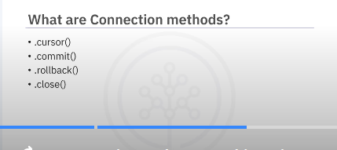
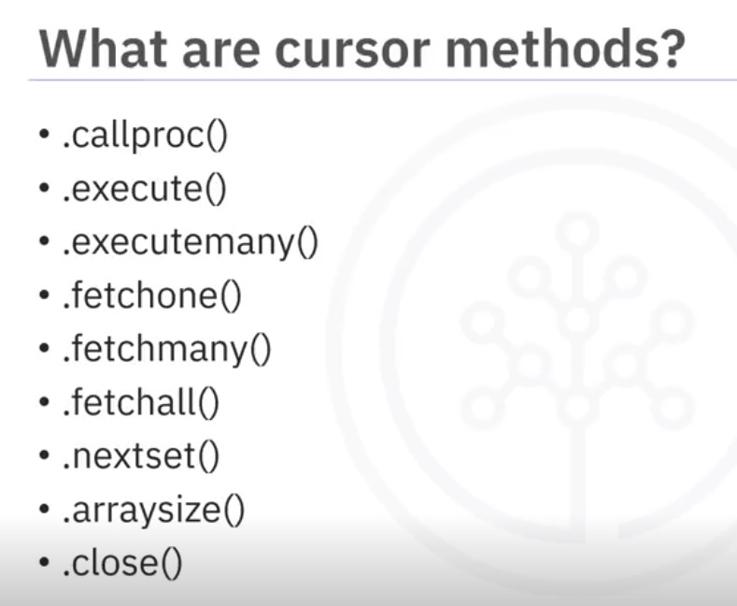
These objects represent a database cursor which is used to manage the content of a fetch operation.
Cursors created from the same connection are not isolated. That is, any changes done to the database by a cursor are immediately visible by the other cursors.
Cursors created from different connections can or cannot be isolated depending on how the transaction support is implemented.

A database cursor is a control structure that enables transversal over the records in a database. It behaves like a file name or file handle in a programming language.
Just as a program opens a file to access its contents, it opens a cursor to gain access to the query results.
Similarly, the program closes a file to end its access, and closes a cursor to end access to the query results.
Another similarity is that just as file handle keeps track of the program's current position within an open file, a cursor keeps track of the program's current position within the query results.
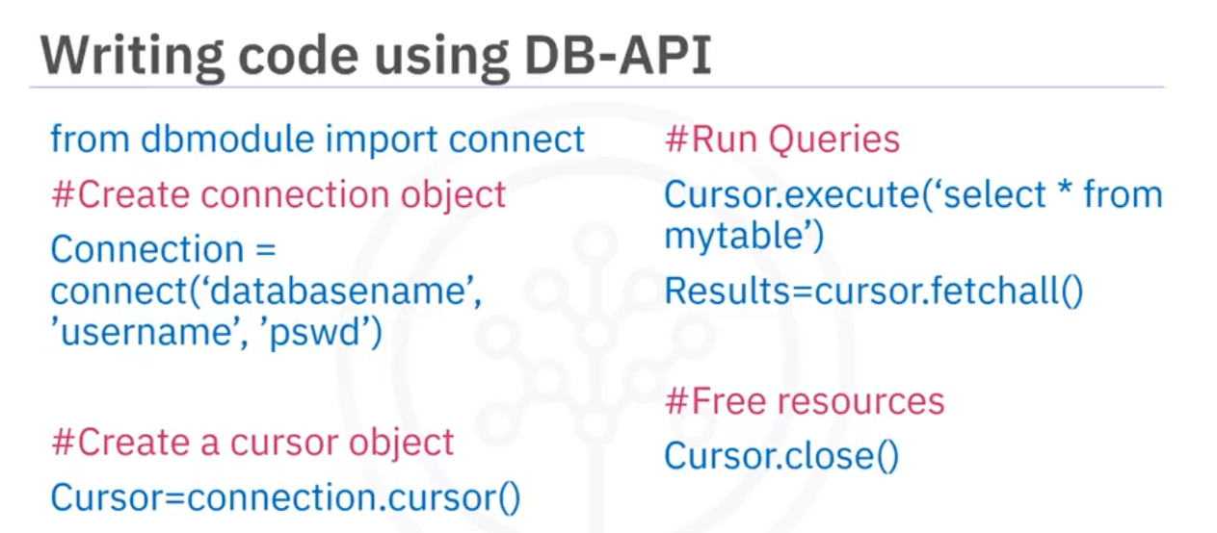INteresante le punto en el que se ve que Pandas puede ejecutar SQL contra una conexión abierta a una base SQL.
conn = sqlite3.connect('INSTRUCTOR.db')
df = pd.read_sql_query("select * from instructor;", conn)

Accessing databases with SQL magic
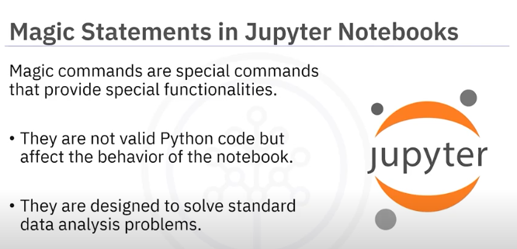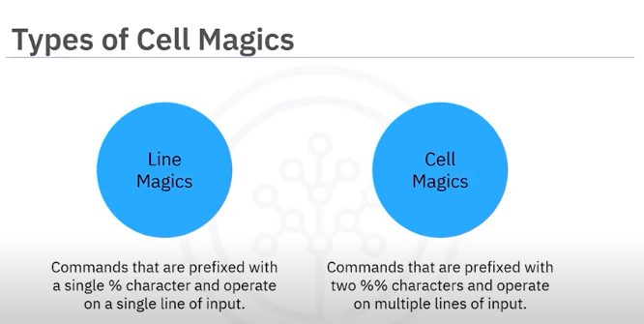There are two types of magic statements in Jupyter notebooks:
- line magics: % operate on a single line of input.
- cell magics.; %% operate on multiple lines of input
Line magics in Jupyter notebooks are commands that are prefixed with a single percentage character and operate on a single line of input.
They are like command line calls in a terminal shell.
On the other hand, cell magics are prefixed with two percentage characters and operate on multiple lines of input.
They can even transform the entire cell or execute the cell in a different programming language
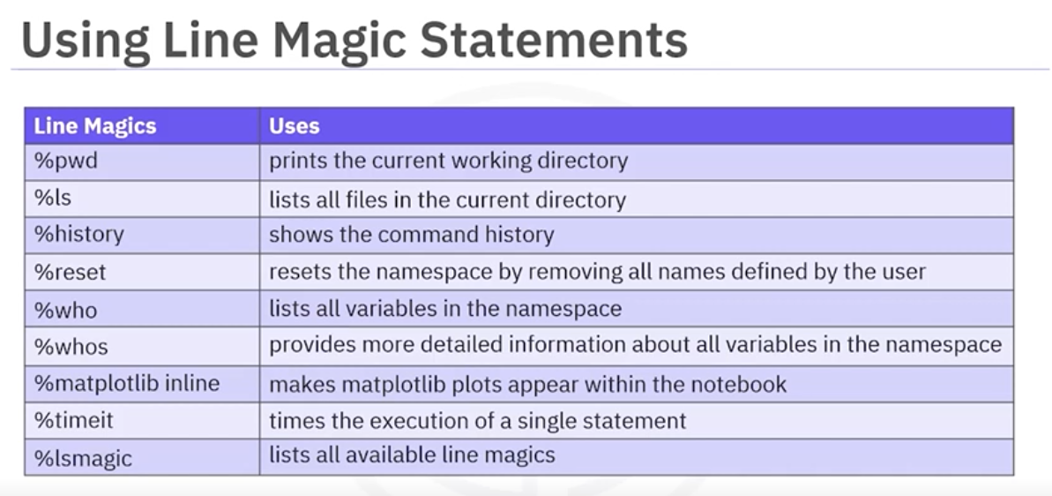

Recuento - magic | type
Family | cell | line | Total Resultado
AsyncMagics |  | 1 | 1
AutoMagics |  | 2 | 2
BasicMagics |  | 12 | 12
CodeMagics |  | 4 | 4
ConfigMagics |  | 1 | 1
DisplayMagics | 6 |  | 6
ExecutionMagics | 6 | 9 | 15
ExtensionMagics |  | 3 | 3
HistoryMagics |  | 3 | 3
KernelMagics |  | 8 | 8
LoggingMagics |  | 5 | 5
NamespaceMagics |  | 13 | 13
OSMagics | 4 | 16 | 20
Other | 11 | 15 | 26
PackagingMagics |  | 5 | 5
PylabMagics |  | 2 | 2
ScriptMagics | 1 | 1 | 2
StoreMagics |  | 1 | 1
Total Resultado | 28 | 101 | 129

Family | type | magic
AsyncMagics | line | autoawait
AutoMagics | line | autocall
AutoMagics | line | automagic
BasicMagics | line | alias_magic
BasicMagics | line | colors
BasicMagics | line | doctest_mode
BasicMagics | line | gui
BasicMagics | line | lsmagic
BasicMagics | line | magic
BasicMagics | line | notebook
BasicMagics | line | page
BasicMagics | line | pprint
BasicMagics | line | precision
BasicMagics | line | quickref
BasicMagics | line | xmode
CodeMagics | line | load
CodeMagics | line | loadpy
CodeMagics | line | pastebin
CodeMagics | line | save
ConfigMagics | line | config
DisplayMagics | cell | html
DisplayMagics | cell | javascript
DisplayMagics | cell | js
DisplayMagics | cell | latex
DisplayMagics | cell | markdown
DisplayMagics | cell | svg
ExecutionMagics | cell | capture
ExecutionMagics | cell | code_wrap
ExecutionMagics | cell | debug
ExecutionMagics | cell | prun
ExecutionMagics | cell | time
ExecutionMagics | cell | timeit
ExecutionMagics | line | code_wrap
ExecutionMagics | line | debug
ExecutionMagics | line | macro
ExecutionMagics | line | pdb
ExecutionMagics | line | prun
ExecutionMagics | line | run
ExecutionMagics | line | tb
ExecutionMagics | line | time
ExecutionMagics | line | timeit
ExtensionMagics | line | load_ext
ExtensionMagics | line | reload_ext
ExtensionMagics | line | unload_ext
HistoryMagics | line | history
HistoryMagics | line | recall
HistoryMagics | line | rerun
KernelMagics | line | autosave
KernelMagics | line | clear
KernelMagics | line | connect_info
KernelMagics | line | edit
KernelMagics | line | less
KernelMagics | line | man
KernelMagics | line | more
KernelMagics | line | qtconsole
LoggingMagics | line | logoff
LoggingMagics | line | logon
LoggingMagics | line | logstart
LoggingMagics | line | logstate
LoggingMagics | line | logstop
NamespaceMagics | line | pdef
NamespaceMagics | line | pdoc
NamespaceMagics | line | pfile
NamespaceMagics | line | pinfo
NamespaceMagics | line | pinfo2
NamespaceMagics | line | psearch
NamespaceMagics | line | psource
NamespaceMagics | line | reset
NamespaceMagics | line | reset_selective
NamespaceMagics | line | who
NamespaceMagics | line | who_ls
NamespaceMagics | line | whos
NamespaceMagics | line | xdel
OSMagics | cell | !
OSMagics | cell | sx
OSMagics | cell | system
OSMagics | cell | writefile
OSMagics | line | alias
OSMagics | line | bookmark
OSMagics | line | cd
OSMagics | line | dhist
OSMagics | line | dirs
OSMagics | line | env
OSMagics | line | popd
OSMagics | line | pushd
OSMagics | line | pwd
OSMagics | line | pycat
OSMagics | line | rehashx
OSMagics | line | sc
OSMagics | line | set_env
OSMagics | line | sx
OSMagics | line | system
OSMagics | line | unalias
Other | cell | bash
Other | cell | file
Other | cell | HTML
Other | cell | perl
Other | cell | pypy
Other | cell | python
Other | cell | python2
Other | cell | python3
Other | cell | ruby
Other | cell | sh
Other | cell | SVG
Other | line | cat
Other | line | cp
Other | line | ed
Other | line | hist
Other | line | ldir
Other | line | lf
Other | line | lk
Other | line | ll
Other | line | ls
Other | line | lx
Other | line | mkdir
Other | line | mv
Other | line | rep
Other | line | rm
Other | line | rmdir
PackagingMagics | line | conda
PackagingMagics | line | mamba
PackagingMagics | line | micromamba
PackagingMagics | line | pip
PackagingMagics | line | uv
PylabMagics | line | matplotlib
PylabMagics | line | pylab
ScriptMagics | cell | script
ScriptMagics | line | killbgscripts
StoreMagics | line | store

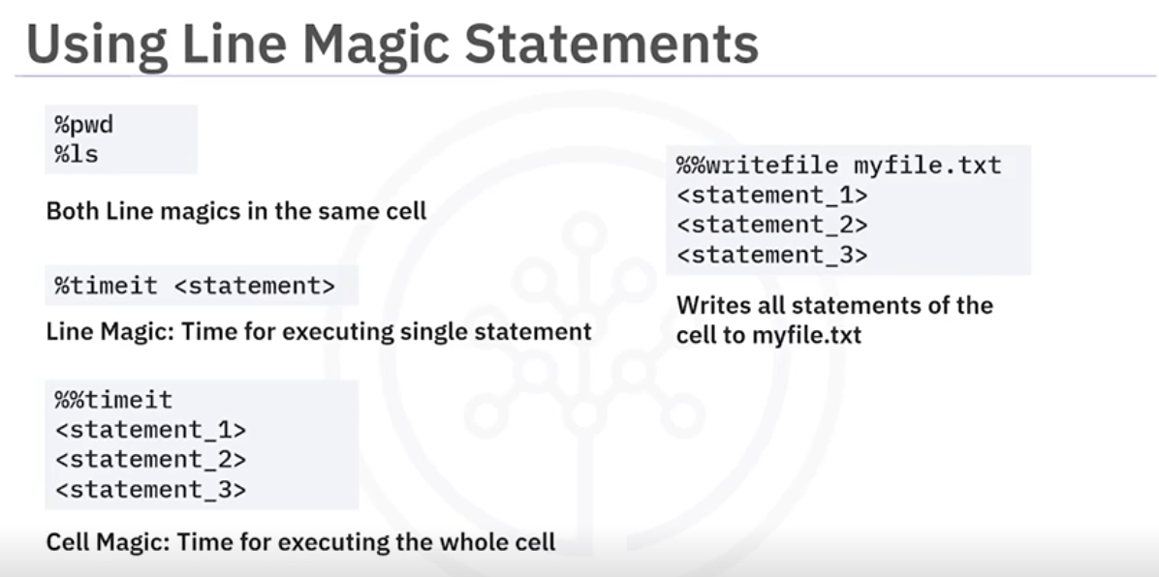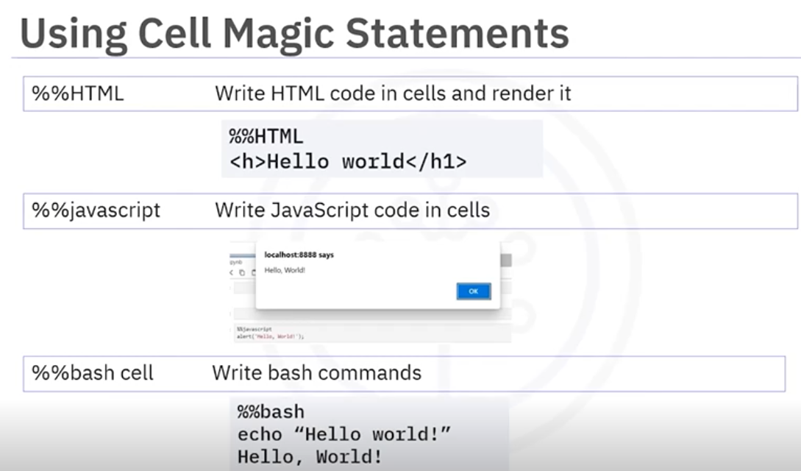
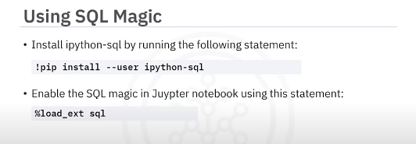
conn = sqlite3.connect('LMCD.db')
!pip install --user ipython-sql prettytable
Import prettytable
prettytable.DEFAULT = 'DEFAULT'
%load_ext sql
%sql sqlite:///LMCD.db
%sql SELECT * FROM INSTRUCTOR
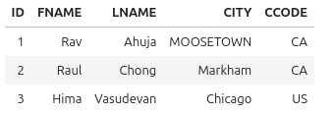

You can use python variables in your SQL statements by adding a ":" prefix to your python variable names.
name = "Raul"
%sql SELECT * FROM INSTRUCTOR WHERE fname = :name

You can use the normal python assignment syntax to assign the results of your queries to python variables.

agrupacion = %sql SELECT CCODE, COUNT(*) FROM INSTRUCTOR GROUP BY CCODE;

You can easily convert a SQL query result to a pandas dataframe using the DataFrame() method. Dataframe objects are much more versatile than SQL query result objects
DF = agrupacion.Dataframe()

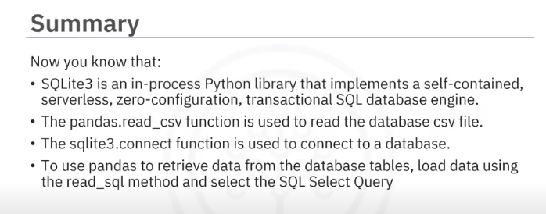Congratulations! You have completed this lesson. At this point in the course, you know:
- Magic commands are special commands that provide special functionalities.
- Cell magics are commands prefixed with two %% characters and operate on multiple input lines.
- DB APIs are commands prefixed with two %% characters and operate on multiple input lines.
- The two main concepts in the Python DB API are Connection Objects and Query Objects.
- A database cursor is a control structure that enables traversal over the records in a database.
- Pandas’ methods are equipped with common mathematical and statistical methods.
- The pandas.read_csv() function is used to read the database CSV file.
- The sqlite3.connect() function is used to connect to a database.
- To use pandas to retrieve data from the database tables, load data using the read_sql method and select the SQL Select Query
- A categorical scatterplot is created using the swarmplot() method by the seaborn package.

MODULO 5

Working with CSV Files

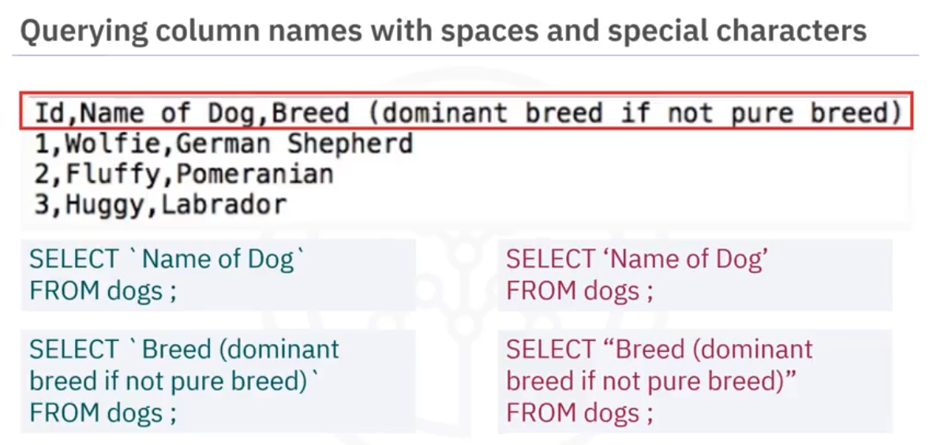

Only Backticks work
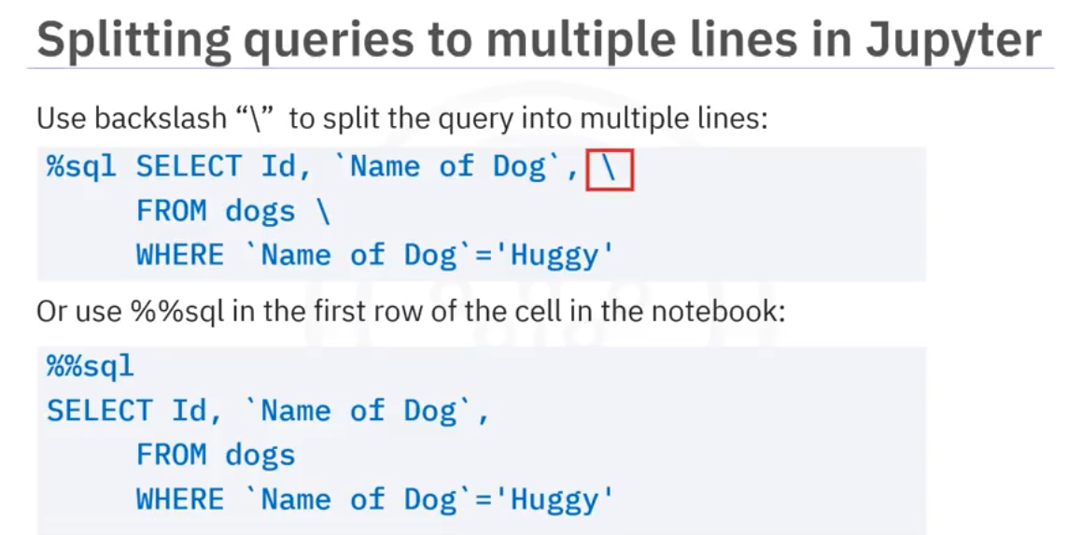

Back Slash no tiene sentido con el doble %

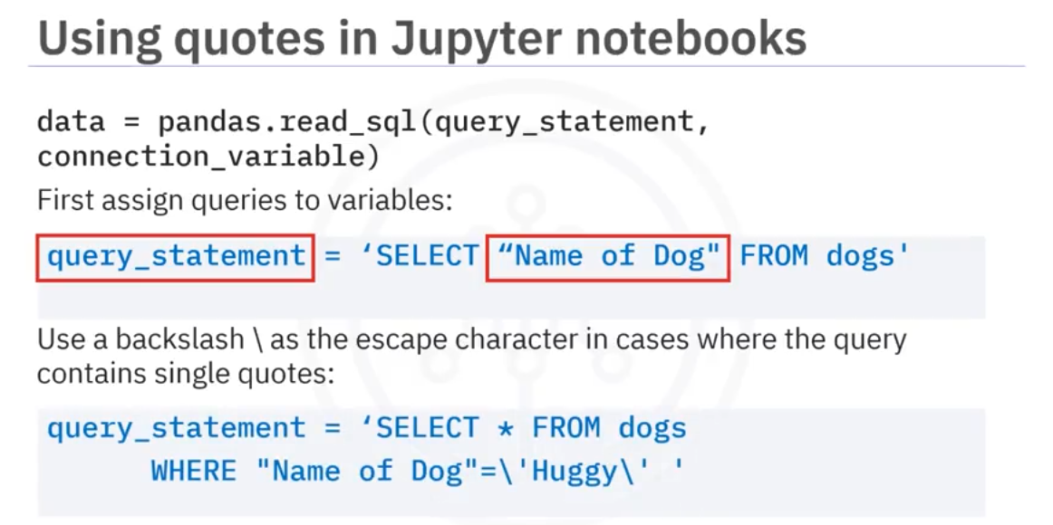
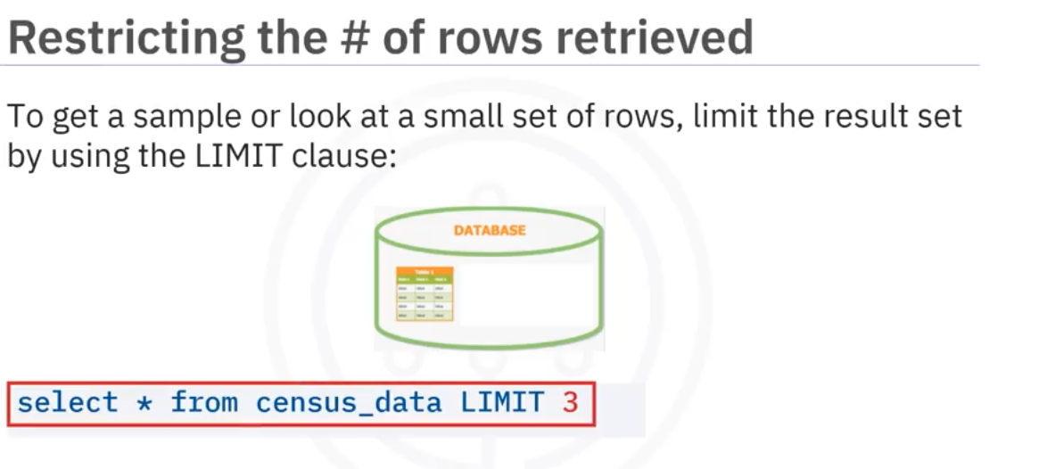
Table and columna Datails
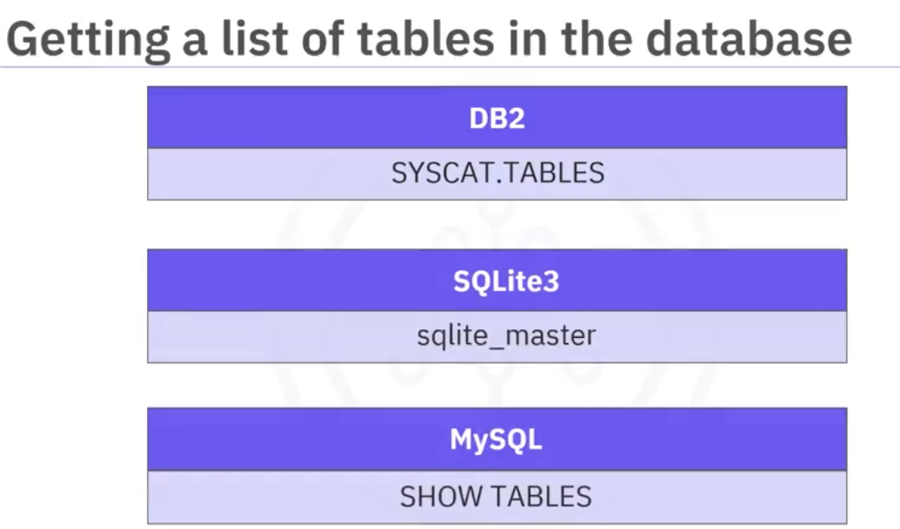
in SQL Server,it's information_Schema.tables

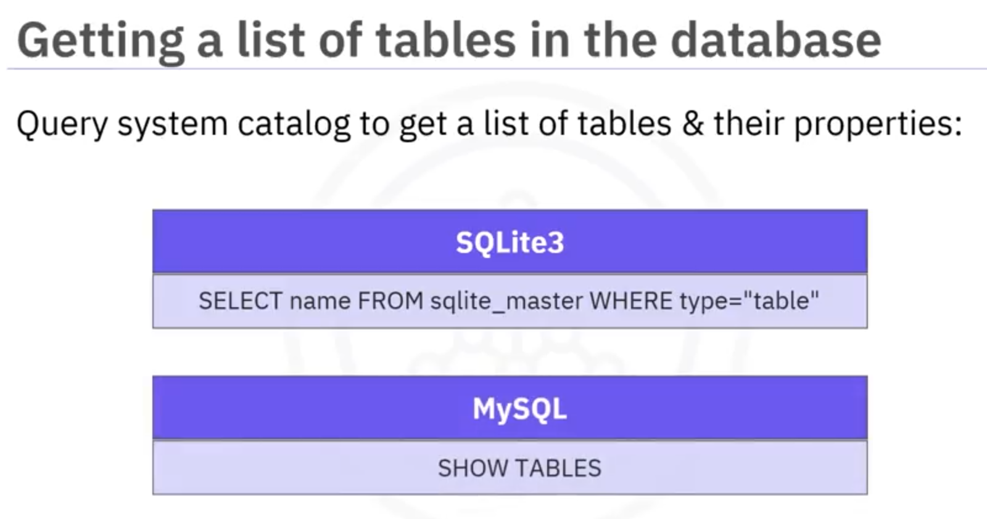
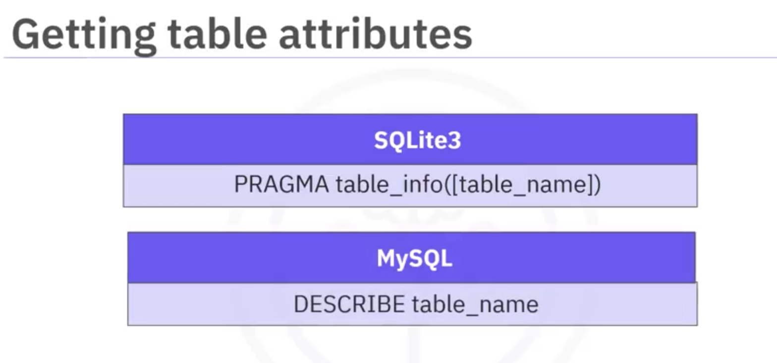

MODULO 6

View
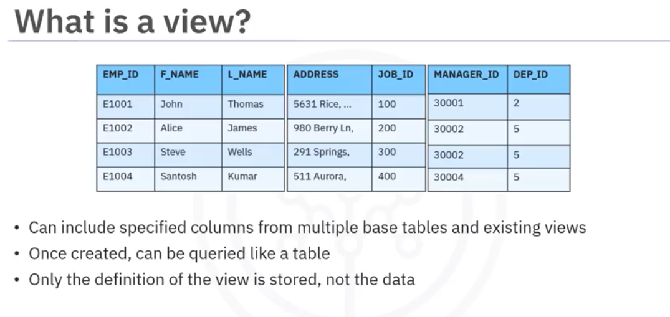
You can also change the data in the base table by running insert, update, and delete queries against the view

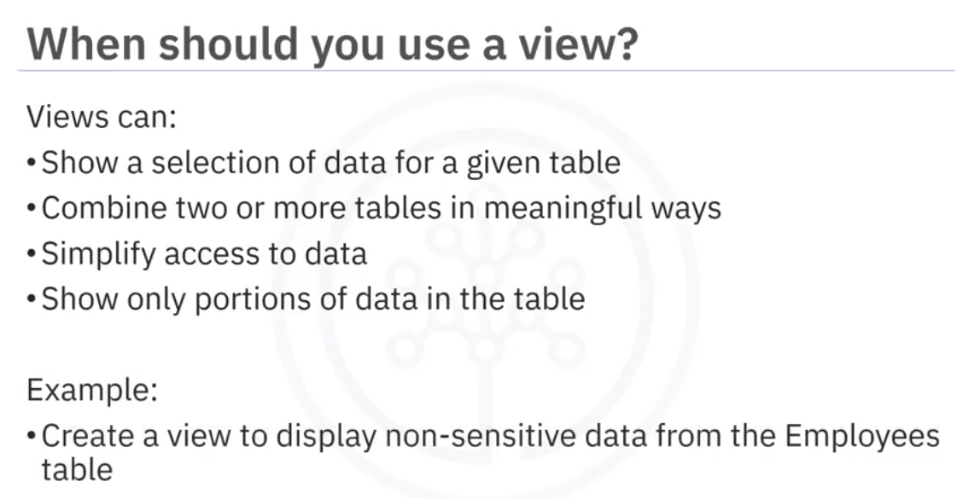

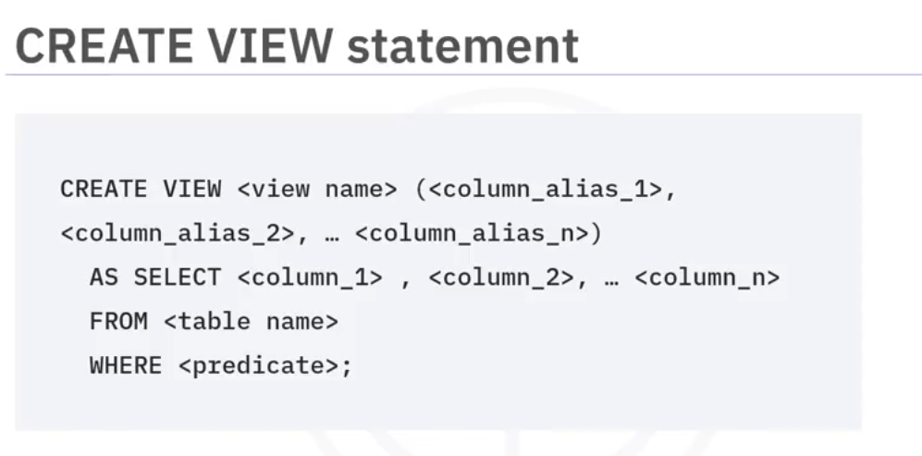
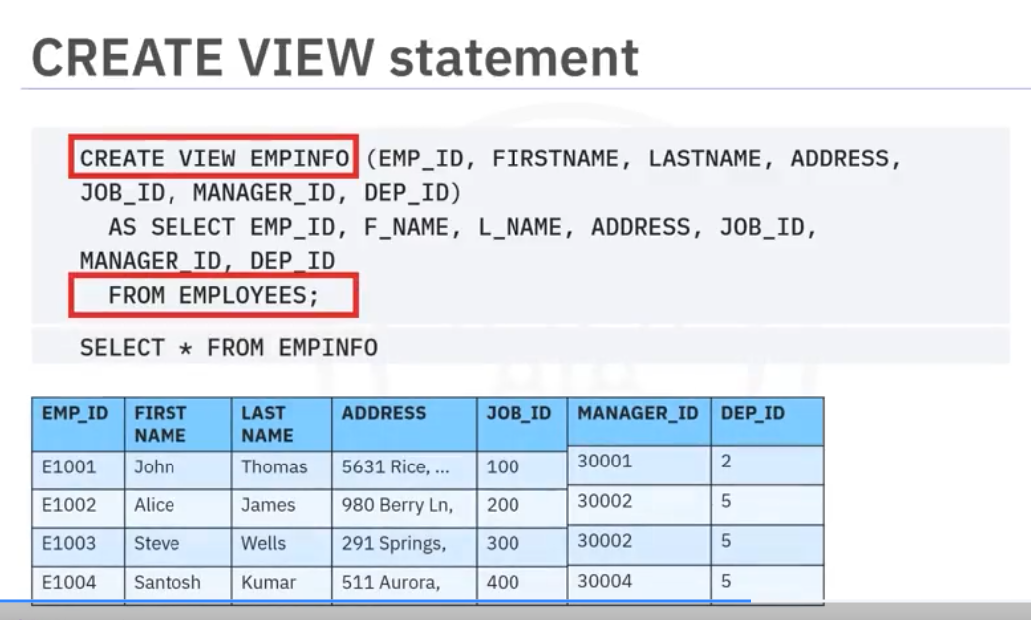
The SELECT statement that you use to create the view can name other views and tables,and it can use the WHERE, GROUP BY, and HAVING clauses. It cannot use the ORDER BY clause or name a host variable
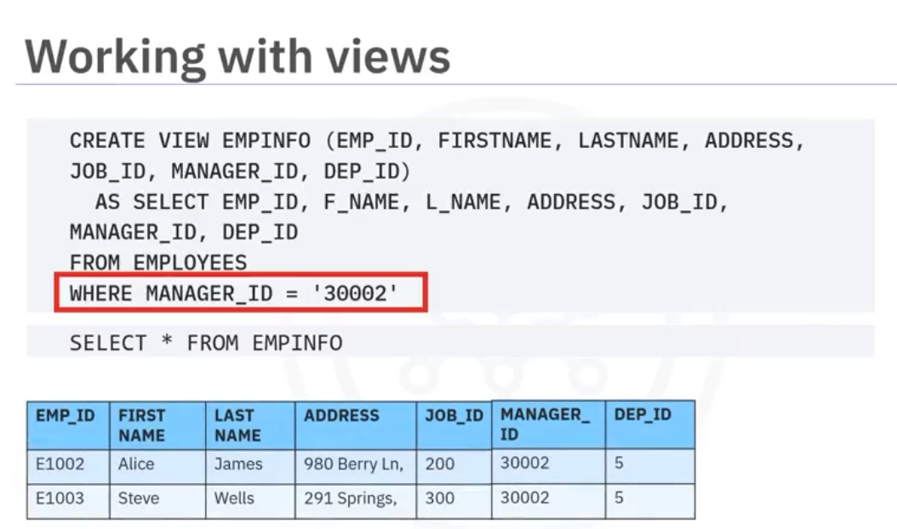
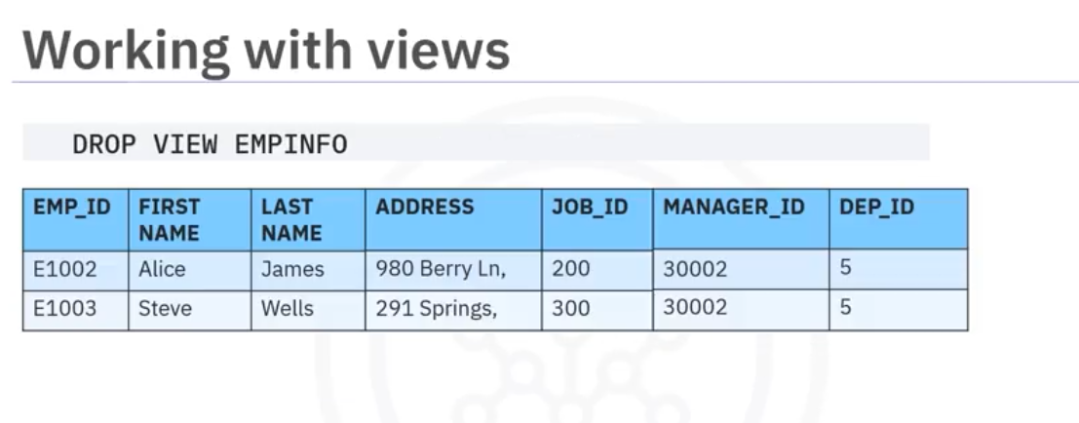
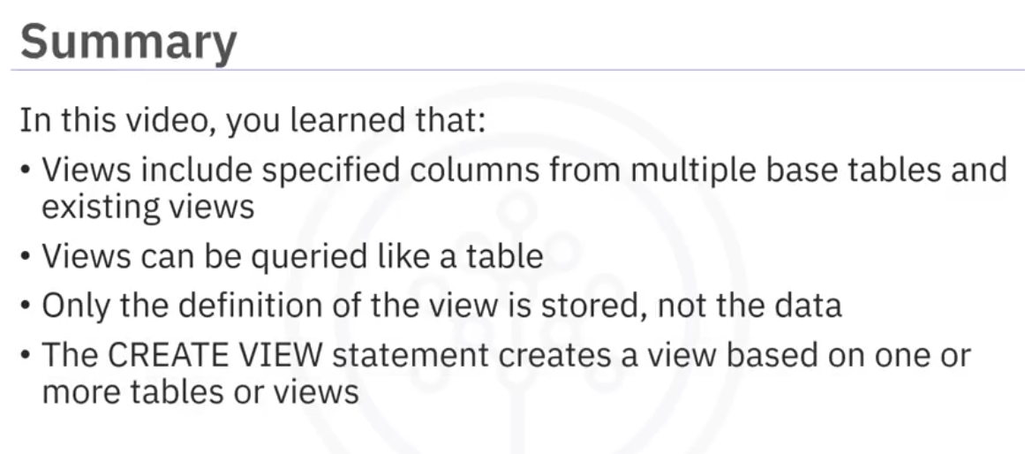

CREATE OR REPLACE VIEW EMPSALARY AS
SELECT EMP_ID, F_NAME, L_NAME, B_DATE, SEX, JOB_TITLE,
MIN_SALARY, MAX_SALARY
FROM EMPLOYEES, JOBS
WHERE EMPLOYEES.JOB_ID = JOBS.JOB_IDENT;

Stored procedures
A stored procedure is a set of SQL statements that are stored and executed on the database server. Instead of sending multiple SQL statements from the client to server, you encapsulate them in a stored procedure on the server and send one statement from the client to execute them.
You can write stored procedures in many different languages. For example, for DB2 on
cloud and DB2, you can write in SQL, PL, PL/SQL, Java, C, or other languages.
They can accept information as parameters, perform, create, read, update, and delete (CRUD) operations, and return results to the client application.
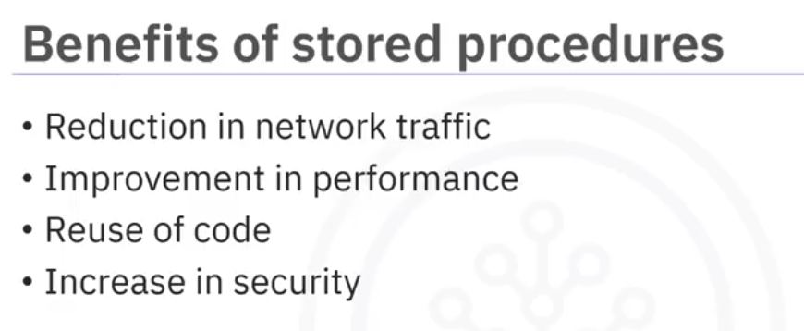
The benefits of stored procedures include:
Reduction in network traffic because only one call is needed to execute multiple statements.
Improvement in performance because the processing happens on the server where the data is stored just the final result being passed back to the client.
Reuse of code because multiple applications can use the same stored procedure for the same job.
Increase in security because:
- you do not need to expose all of your table and column information to client-side developers.
- you can use server-side logic to validate data before accepting it into the system.
Remember though, that SQL is not a fully fledged programming language. You should not try to write all of your business logic in your stored procedures.
Let's look at how to create a stored procedure in SQL.
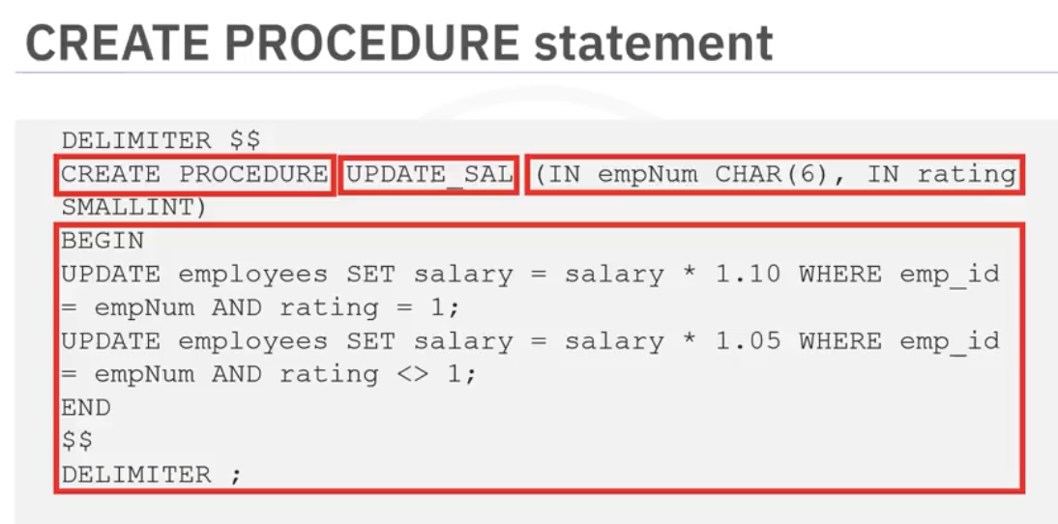
Firstly, you use the create procedure statement, specifying the name of the procedure, and any parameters which it will take.
In this example, the update_sal procedure will take an employee number and rating which it will use to update the employee's salary by an amount depending on their rating.
Then you declare the language you are using.
You then enclose your procedural logic in the begin and end statements.
Notice that you can use the information passed to the procedure, the parameters, directly in your procedural logic.
Also, since the stored procedure is going to use multiple statements, it is prudent to change the delimiter, the character that marks the end of a statement, before we start defining the procedure. Here it has been set to dollar sign dollar sign. Use of this delimiter dollar sign dollar sign in the code will then mark the end of the procedure commands. Finally, we change the delimiter back to semicolon when we are done.
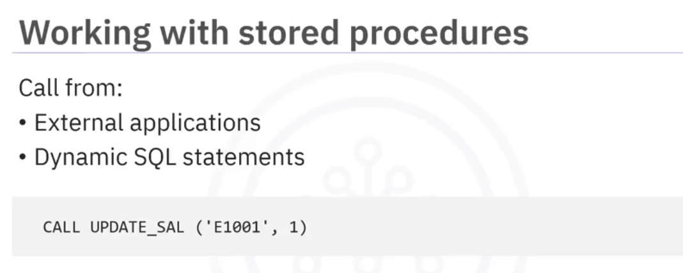
You can call stored procedures from your external applications or from dynamic SQL statements. To call the update _SAL stored procedure that we just created, you use the call statement with the name of the stored procedure and pass the required parameters. In this case, the employee ID and the rating for that employee.

ACID

